

Bachelor of Science in Computer Science Session (2010-2024 Fall)

Submitted By:

STUDENT1 NAME STUDENT2 NAME

SUPERVISOR
Supervisor Name
Lecturer
School of Computer Science

SCHOOL OF COMPUTER SCIENCE MINHAJ UNIVERSITY, LAHORE

Project

Submitted in Partial Fulfillment

of the Requirements for the Degree of

Bachelor of Science in Computer Science
at the

Minhaj University, Lahore

by

STUDENT1 NAME Reg.No. STUDENT2 NAME Reg.No.

Supervisor Name  Supervisor  School of Computer Science | Dr. Gulzar Ahmad  Head School of Computer Science

It is declared that this is an original piece of my work, except where otherwise acknowledged in text and references. This work has not been submitted in any form for another degree or diploma at any university or other institution for tertiary education and shall not be submitted by me in future for obtaining any degree from this or any other University or Institution. I am the responsible if I do not meet the deadline.

Name of Student 1 Signature: Reg. No. XYX

Name of Student 2 (if any) Signature: Reg. No.



DEDICATION

To

My Mother

Who always wished or prayed for my success, for supporting and encouraging me to believe in myself, who always sacrificed so much for me.

My Father

For earning an honest living for me, for supporting and encouraging me to believe in myself.

My Teacher

For their support and wishes.

CERTIFICATE OF APPROVAL
It is certified that the project titled “Multiplayer Battle Arena” carried out by Studenr Name, Reg. No., under the supervision of XYZ, Minhaj University Lahore, is fully adequate, in scope and in quality, as a final year project for the degree of BS of Computer Science.

Supervisor: --------------------------------
Supervisor Name
Lecturer
School of Computer Science Minhaj University Lahore

Internal Examiner 1: -------------------------------
School of Computer Science Minhaj University Lahore

Internal Examiner 2: --------------------------------
School of Computer Science Minhaj University Lahore

FYP Coordinator: --------------------------------
Shoaib Saleem
Lecturer
School of Computer Science Minhaj University Lahore

Head of Department: -----------------------------------
Dr. Gulzar Ahmad
School of Computer Science Minhaj University Lahore

ACKNOWLEDGEMENT

First of all, I am thankful to Allah Almighty, the most beneficial and merciful who gave me the courage and guidance to complete my project. I offer my special praise for our beloved Holy Prophet Hazrat Muhammad (S.A.W) who is the symbol of knowledge and guidance of humanity as a whole. I like to express my special thanks of gratitude to my supervisor XYZ for his support. His steadfast support of this project was greatly needed and deeply appreciated. Last but not least, no acknowledgement could ever express our obligations to our loving parents for their love, affection, amiable, advices and prayers for my success.

ABSTRACT

According to your domain students summarize the abstract including two lines of introduction, one line for positivity, other line for weakness and discuss simulations with final outcomes, mention all scenarios, describe your abstract in maximum 500 words in single paragraph.
Steps for Writing the Abstract:
- Start with the problem statement
- Describe the research method
- Summarize your findings
- End with the conclusion

TABLE OF CONTENTS

CHAPTER 1 INTRODUCTION 1
  - Background 2
  - Goals and Objectives 2
  - Gap Analysis 2
  - Project Plan 3
    - Work Breakdown Structure 3
    - Gantt Chart 4
    - Team Members 5
  - Report Outline 5
CHAPTER 2 SYSTEM REQUIREMENTS AND SPECIFICATION 6
  - Purpose 7
    - Document Conventions 7
    - Intended Audience 7
  - Overall Description 8
    - Service Perspective 8
    - Service Function 8
    - Product Functions 8
    - User Classes and Characteristics 9
    - Assumptions and Dependencies 9
  - External Interface Requirements 9
    - User Interfaces 9
    - Hardware Interface 10
    - Game Interface 10
  - System Features 10
    - User Login 10
    - Logout 11
    - Edit Settings 11
    - Play Online 12
  - Other Nonfunctional Requirements 12
    - Performance Requirements 12
    - Safety Requirements 12
    - Software Quality Attributes 13
  - Other Requirements 13
CHAPTER 3 USECASE ANALYSIS 14
  - Use Case Model 15
  - Fully Dressed Use Cases 16
CHAPTER 4 SYSTEM DESIGN 28
  - Architecture Diagram 29
  - Domain Model 30
  - Class Diagram 32
  - Sequence / Collaboration Diagram 33
  - Operation Contracts 34
  - Activity Diagram 37
  - State Transition Diagram (Login) 38
  - State Transition Diagram (Edit Settings) 39
  - State Transition Diagram (Join Game Lobby) 40
  - State Transition Diagram (Create Lobby) 41
  - State Transition Diagram (Start Game) 42
  - Component Diagram 43
  - Deployment Diagram 44
  - Game Interference 45
    - Splash Screen 45
    - Login Screen 46
    - Main Menu Screen 47
    - General Settings 48
    - Graphics Settings 49
    - Audio Settings 50
    - Controls Settings 51
    - Create Lobby Team Death Match Mode 52
    - Create Lobby Capture of Flag Mode 53
    - Create Lobby Free for All 54
    - Lobby 55
    - Gameplay 56
    - Scoreboard 57
CHAPTER 5 IMPLEMENTATION 58
  - Important Flow Control 59
  - Components, Libraries And Stubs 60
  - Deployment Environment 60
  - Tools and Techniques 60
  - Best Practices / Coding Standards 61
CHAPTER 6 TEST AND EVALUATION 62
  - Testing and Evaluation 63
  - Use Case Testing 63
  - Boundary Value Analysis 65
  - Performance Testing 66
  - Stress Testing 69
  - Improvement 70
REFERENCES 71

Table 1.1 Team Member 5

Table 3.1 Use Case<01> 17

Table 3.2 Use Case<02> 19
Table 3.3 Use Case<03> 21
Table 3.4 Use Case<04> 23

Table 3.5 Use Case<05> 25

Table 3.6 Use Case<06> 27

Table 4.1 Operation Contracts-01 34

Table 4.2 Operation Contracts-02 34

Table 4.3 Operation Contracts-03 35

Table 4.4 Operation Contracts-04 35

Table 4.5 Operation Contracts-05 36

Table 4.6 Operation Contracts-06 36

Table 6.1 Use Case Testing-01 64

Table 6.2 Use Case Testing Extension 65

Table 6.3 Performance Testing 01 66

Table 6.4 Performance Testing 02 66

Table 6.5 Performance Testing 03 67

Table 6.6 Performance Testing 04 67

Table 6.7 Performance Testing 05 68

Table 6.8 Performance Testing 06 68

Figure 1.1 Word Breakdown Structure 3
Figure 1.2 Gantt Chart 4
Figure 3.1 Use Case Model 15
Figure 3.2 Login Use Case 16
Figure 3.3 Edit Profile Use Case 18
Figure 3.4 Join Game Lobby Use Case 20
Figure 3.5 Create Lobby Use Case 22
Figure 3.6 Start Game Use Case 24
Figure 3.7 End Game Use Case 26
Figure 4.1 Architecture Diagram 29
Figure 4.2 Domain Model 30
Figure 4.3 Entity Relationship Diagram 31
Figure 4.4 Class Diagram 32
Figure 4.5 Sequence / Collaboration Diagram 33
Figure 4.6 Activity Diagram 37
Figure 4.7 State Transition Diagram (Login) 38
Figure 4.8 State Transition Diagram (Edit Settings) 39
Figure 4.9 State Transition Diagram (Join Game Lobby) 40
Figure 4.10 State Transition Diagram (Create Lobby) 41
Figure 4.11 State Transition Diagram (Start Game) 42
Figure 4.12 Component Diagram 43
Figure 4.13 Deployment Diagram 44
Figure 4.14 Splash Screen 45
Figure 4.15 Login Screen 46

Figure 4.16 Main Menu Screen 47
Figure 4.17 General Settings 48
Figure 4.18 Graphics Settings 49
Figure 4.19 Audio Settings 50
Figure 4.20 Controls Settings 51
Figure 4.21 Create Lobby Team Death Match Mode 52
Figure 4.22 Create Lobby Capture of Flags Mode 53
Figure 4.23 Create Lobby Free for All 54
Figure 4.24 Lobby 55
Figure 4.25 Gameplay 56
Figure 4.26 Scoreboard 57
Figure 5.1 Important Flow Control 59

CHAPTER 1 INTRODUCTION

In this chapter I am introducing the main steps of my project. This introduction contains the background, Goals/Objectives, Solutions, Gap Analysis, Gantt chart, Project Plan, Report outline. This material of introduction helps to understand the main issues related to this project.

Background

Online shooting games have become incredibly popular, allowing players worldwide to compete against each other in virtual combat. They originated in the 1990s with games like "Doom" and "Quake" and have since evolved with improved graphics, larger battles, and diverse gameplay mechanics. Online platforms and cross-platform play have facilitated connectivity among players, and future advancements in technology promise even more immersive experiences.

Goals and Objectives

The objective of online shooting games is to engage in multiplayer battles, defeat opponents, and secure victory. These games encourage teamwork, offer progression and rewards, cater to esports competitions, facilitate social interaction, and provide an immersive and enjoyable gaming experience.

Gap Analysis

Now a day there are many trending shooting games with a number of traffic of users but some of the features of these games are difficult to understand by some users. Multiplayer Battle Arena provides a user-friendly interface in which the features are very easy to understand., So, features of this game are better than other games in which user can easily play the game without any delay and enjoy the mechanism of the game without any restrictions.

Project Plan

Details: In this game user make a profile by providing a unique username, and after that he/she is able to play the game with the multiple players in the world wide.
Features: The different type of features all over the game will be up to date and new features will implement regularly.

Work Breakdown Structure
The Work Breakdown Structure (WBS) for a game development project includes the Concept Phase, involving market research, target audience definition, concept ideation, and selection. The Design Phase encompasses game mechanics, level and character design, story development, UI design, and art style selection. Art Assets Creation covers 2D and 3D art, sound and music, and special effects. Programming and Development includes engine selection, core mechanics implementation, level design, AI development, UI programming, and bug fixing. Lastly, Quality Assurance (QA) and Testing involve functional and compatibility testing, as well as playtesting and balancing activities.
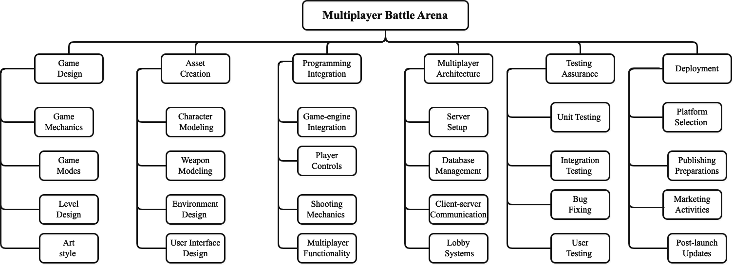

Figure 1.1 Word Breakdown Structure

Gantt Chart
A Gantt chart for game development is a project management tool that visually represents the various tasks and stages involved in creating a game. It breaks down the development process into smaller, manageable tasks, such as design, art, programming, and testing, and arranges them on a timeline. The chart shows the duration of each task, task dependencies, and important milestones. Team members can be assigned to specific tasks, and progress is regularly updated to track actual progress against the planned schedule. By using a Gantt chart, game developers can effectively plan, coordinate, and monitor the development process, ensuring a smoother and more efficient game creation journey.
In summary, a Gantt chart is a game development roadmap that streamlines the project's tasks, resources, and timelines. It keeps the development team organized, improves communication, and enables better decision-making, ultimately leading to a successful and well-managed game development process.
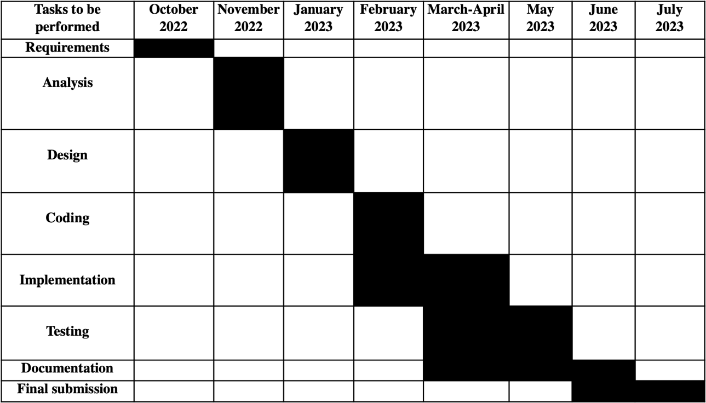

Figure 1.2 Gantt Chart

Team consists of

      - Project Manager (PM)
      - Requirement Analyst (RA)
      - Backend Developers

      - Frontend developers
      - Testing Engineering (TE)

Each member has some specific skills which they used efficiently in project. A table in given to show team members names, their skills and their task description.
Table 1.1 Team Member

Name | Skills | Description
Haider Raza | Back-end Developers Front-end Developer | Involved in coding  Design The User Interface

Report Outline

Multiplayer Battle Arena provides a friendly user interface to the users. All the features are easy to understand.
- Game modes: Team Deathmatch, Free for All, and Capture of Flag.
- Player team system.

- Shooter AI (Bots).
- 6 different types of weapons: Rifle, Sniper, Shotgun, Pistol, Grenade, and Knife.
- Walk, Slide, Jump, Crouch, Shoot, Die, and Run player animations.

CHAPTER 2

SYSTEM REQUIREMENTS AND SPECIFICATION

The purpose of an online shooting game is to provide an exhilarating and immersive gaming experience. Players engage in virtual combat, showcasing their skills, strategic thinking, and teamwork. These games offer entertainment and escapism, allowing players to enter thrilling virtual worlds. They foster social interaction by enabling players to team up with friends and join communities. With intense gameplay and a sense of achievement, online shooting games aim to deliver adrenaline-pumping action. The ultimate goal is to create an enjoyable and memorable experience that keeps players engaged and coming back for more.

Document Conventions

When writing the SRS document for "Multiplayer Battle Arena" the following terminologies are used to make the document more effective and readable we used font:
      - Times New Roman
      - Line spacing: 2 line spacing

      - Font Size: 12pt
      - headings: 16pt
      - Headings are bold.
This document is intended to the audience and also for those End Users who really want to know for what purpose this game is developed for.

Intended Audience

People of all age groups owing a computer system or laptop.

Service Perspective

The online 3d multiplayer shooting game is developed to help people communicate during the game with others easily. The game is developed using c sharp as programming language and design and coded in Unity 3D.

Service Function

The main function of this project is the multiplayer matchmaking and player communicating. These functions enhance the gaming experience by facilitating fair match ups and enabling collaboration among players.

Product Functions

Features

      - Login (as guest)
      - Matchmaking
      - Chat Communication
      - Multiple play modes
      - Spectator Mode

      - Graphics Settings

User Function

      - Login
      - Select Mode
      - Edit Settings
      - Play Game-play

Admin
The administrator can add, edit or delete user’s accounts. Admin manages all functionality of Multiplayer Battle Arena.

Design and Implementation Constraints:

      - The device will have 8GB RAM.
      - Good quality Internet connection required.

      - Operating System Windows or Macintosh.

Tools
      - Unity 3D
      - Photon Unity Networking
      - C#

2.2.5. Assumptions and Dependencies

In this game, the user must login as a guest. User must have a computer or laptop and at least 4 GB Ram in system. Also, the user must have internet access because Multiplayer Battle Arena is an online game.

External Interface Requirements

User Interfaces

The game provides a user-friendly and interactive user interface. In this game, the user will easily understand the use of every element and enjoy the user experience.
User can interact with following things:

      - User can play the game in multiple modes.
      - Chat with your team members while in the match.

      - Processor: i3
      - Hard Disk: 5 GB
      - Memory: 4 GB RAM

      - Laptop or computer.

Game Interface

      - Unity 3D
      - Photon Unity Networking
      - C#

System Features

User Login

Description Priority
User Login has a priority value. Whenever the user installs the game and working for the first time, he/she has to get login first as a guest

Stimulus/Response Sequences
      - The game launched from the login screen.
      - User is prompted to main menu.

Functional Requirements
User gets registered and is able to use the game.

Description and Priority
User has to authenticate if he/she is not logged in. He/she can also log out if wanted. This feature has 2nd highest priority at most.

Stimulus/Response Sequences
      - The game launched from the login screen.
      - User is prompted to main menu.
      - Multiple options show to play the game.

      - If the user is logging out, simply user back to login screen.

Functional Requirements
User gets logged in/ logged out

Edit Settings

Description and Priority
This feature is specifically for those users who want to change the settings according to their systems.

Stimulus/Response Sequences
      - The user chooses settings option from main menu.
      - Change settings according to his requirements.

Functional Requirements
User must be logged in and stay connected with internet.

Description and Priority
This feature is specifically for those users who want to play game online.

Stimulus/Response Sequences
      - The user can play the game with online people.
      - User can play the game in 3 different modes.

Functional Requirements
User must be logged in and stay connected with internet.

Other Nonfunctional Requirements

Performance Requirements

      - System device should have Window or Macintosh operating system.
      - User must have a good internet connection to really enjoy the performance of game.
      - Size of the game should be small that it can be accessible in every system if system is low storage device.

Safety Requirements

Only authorized member or user can log in into a game. Data should be saved in encrypted form so that in case of attack or hack data will be unreadable or unacceptable.

Privacy and security of the user is our basic and most important motive.

Availability
Users can access their accounts anytime anywhere.

Integrity
Better component design to get better performance at peak time.

Correctness
Game is design in that way that it should be free from errors.

Reliability
Game is reliable and the user can trust that it's 100% reliable.

Security
Game is 100% secure and users save their data with no worry. Before storing data on a database, data is encrypted so that no one can access or steal user's personal information.

Easy to Use
Game is easy to use and learn.

Other Requirements

The system must store the entire User information. For each user data saved with its unique id in the database.

CHAPTER 3 USECASE ANALYSIS

A use case model is a visual representation in software development that describes how users interact with a system to achieve specific tasks or goals. It consists of use cases, which represent individual functionalities or interactions, and actors, who are the users or external entities interacting with the system.
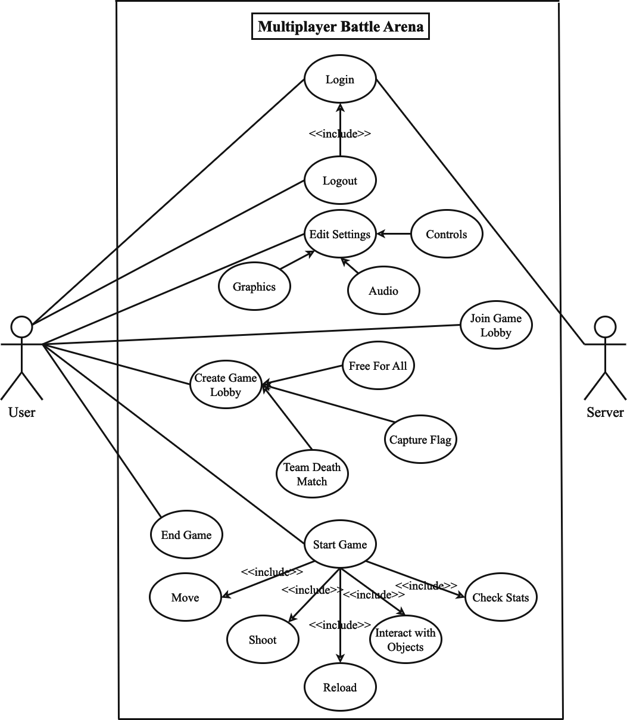

Figure 3.1 Use Case Model

Guest Login

The "Guest Login" use case for a this game represents a scenario where a player can access and play the game without the need to create an account or log in with formal credentials. Here's a description of the "Guest Login" use case for a shooting game:
The "Guest Login" use case in a shooting game allows players to quickly jump into the action without the friction of creating an account. It caters to casual players who want to experience the game without any commitment, while still providing them with an enjoyable gaming experience.
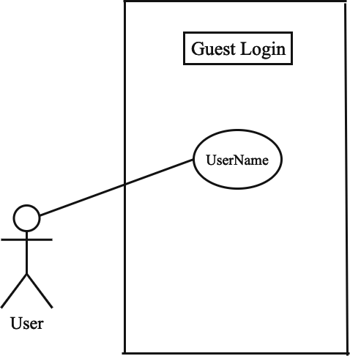

Figure 3.2 Login Use Case

Table 3.1 Use Case<01>

Fully Dressed Use Case
• | Use Case Name | Guest Login
• | Scope | Login
• | Level | User goal
• | Actor | User, Server
• | Stakeholder | User, Server
• | Pre-Condition | Internet Connection
• | Post-Condition | Access to game
• | Success Scenario | Successfully Login

Edit Settings

The "Edit Settings" use case in a multiplayer shooting game represents a scenario where the player wants to customize various game settings to tailor the gameplay experience to their preferences. The setting for this game includes:
- General Settings
- Audio Settings

- Graphics Settings

- Controls Settings
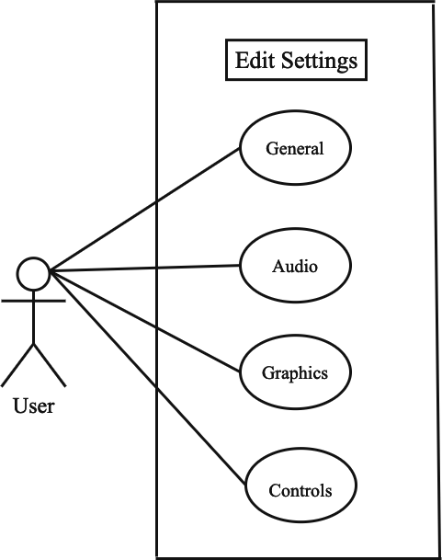

Figure 3.3 Edit Profile Use Case

Table 3.2 Use Case<02>

Fully Dressed Use Case
• | Use Case Name | Edit Setting (General, Graphics, Audio, Control)
• | Scope | Settings
• | Level | User Goal
• | Actor | User
• | Stakeholder | User
• | Pre-Condition | Internet connection  Must be login
• | Post-Condition | Settings should be edit
• | Success Scenario | Settings edit successfully

Join Game Lobby

The "Join Lobby" use case in a shooting game represents a scenario where a player wants to join an existing multiplayer lobby to participate in online matches with other players. The "Join Lobby" use case is a crucial aspect of a shooting game, as it allows players to engage in real- time battles with other players, fostering competition and community engagement. By providing a seamless and user-friendly lobby joining process, the game enhances the overall multiplayer experience and keeps players immersed in dynamic and challenging gameplay. Randomly join the looby in this game.
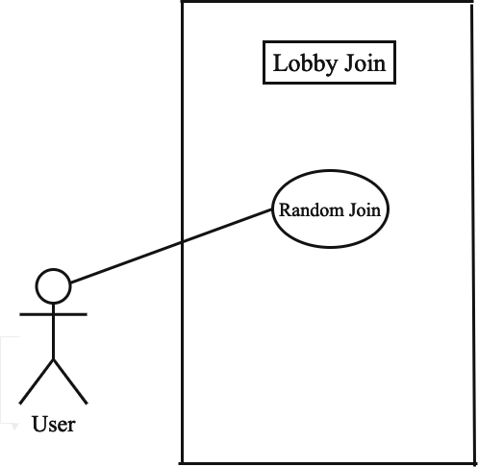

Figure 3.4 Join Game Lobby Use Case

Table 3.3 Use Case<03>

Fully Dressed Use Case
• | Use Case Name | Join Game Lobby
• | Scope | Lobby
• | Level | User Goal
• | Actor | User
• | Stakeholder | User
• | Pre-Condition | Must be Login Internet Connection
• | Post-Condition | Join any lobby
• | Success Scenario | Lobby joined successfully.

Create Game Lobby

The "Create Lobby" use case in a shooting game represents a scenario where a player wants to create a new multiplayer lobby to host a custom game session and invite other players to join. The "Create Lobby" use case empowers players to have control over the multiplayer experience by enabling them to create customized game sessions with friends or other players. It enhances social interaction and player engagement within the shooting game, fostering a sense of community and camaraderie among players. To create the lobby there are three different modes for this game:
- Free for all
- Team death match
- Capture the flags
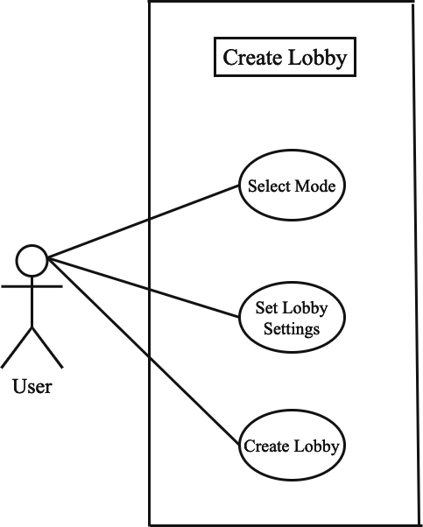

Figure 3.5 Create Lobby Use Case

Table 3.4 Use Case<04>

Fully Dressed Use Case
• | Use Case Name | Create Game Lobby
• | Scope | Lobby
• | Level | User Goal
• | Actor | User
• | Stakeholder | User
• | Pre-Condition | Must be Login Internet Connection  User must have to select mode  User must set all settings for the mode
• | Post-Condition | Create a new lobby
• | Success Scenario | Lobby created Successfully

Start Game

The "Start Game" use case in a shooting game represents a scenario where a player initiates the beginning of a single-player or multiplayer match. The "Start Game" use case is critical in providing players with the opportunity to begin their shooting game experience, whether in a single-player campaign or a competitive multiplayer match. It ensures a smooth and engaging transition from the main menu or lobby to the actual gameplay, providing players with thrilling and immersive shooting game action.
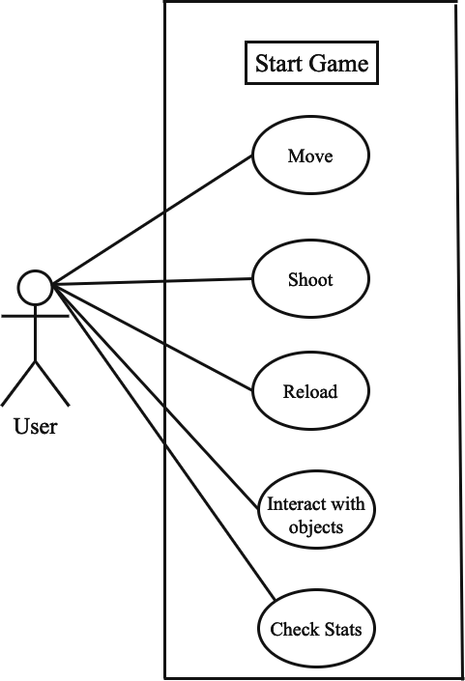

Figure 3.6 Start Game Use Case

Table 3.5 Use Case<05>

Fully Dressed Use Case
• | Use Case Name | Start Game
• | Scope | Game
• | Level | User Goal
• | Actor | User
• | Stakeholder | User
• | Pre-Condition | Must be Login Internet Connection  User must be join/create lobby
• | Post-Condition | Start Game
• | Success Scenario | Game started successfully

End Game

The "End Game" use case in a shooting game represents a scenario where the game session concludes, and the player's participation in the match or campaign comes to an end. The "End Game" use case ensures a smooth and satisfying conclusion to each game session, providing players with feedback on their performance and achievements. It offers closure to the gaming experience while also encouraging players to continue their journey in the shooting game, whether through progression to the next level or exploring other gameplay options.
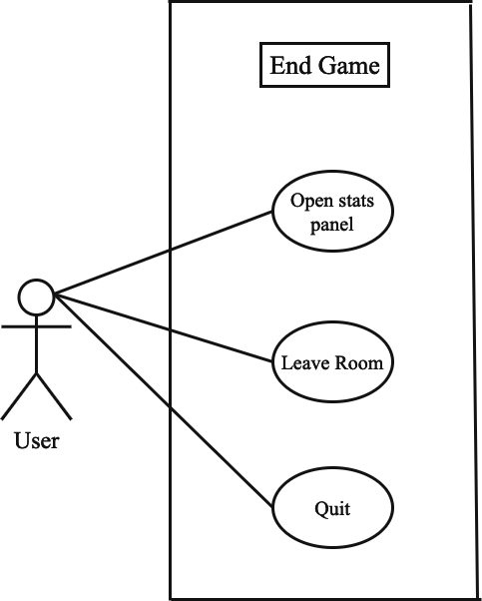

Figure 3.7 End Game Use Case

Table 3.6 Use Case<06>

Fully Dressed Use Case
• | Use Case Name | End Game
• | Scope | Game
• | Level | User Goal
• | Actor | User
• | Stakeholder | User
• | Pre-Condition | Must be Login  Internet Connection
• | Post-Condition | Game End
• | Success Scenario | Game Ended Successfully

CHAPTER 4 SYSTEM DESIGN

The system design describes the system requirement, operating environment system and subsystem architecture, files and database design, input format, output layout, user interface, detailed design processing logic, an external interface.

Architecture Diagram

We divided system architecture in three-part Game, services & authentication and Photon Unity Networking (PUN), As Shown in the figure.
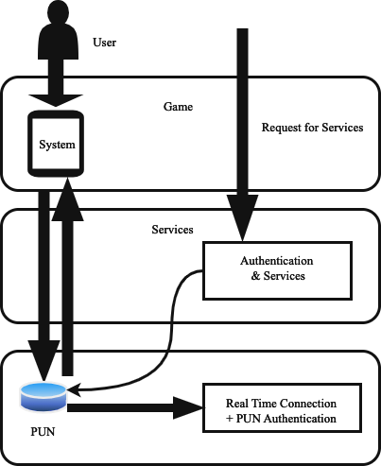

Figure 4.1 Architecture Diagram

The multiplayer shooting game's domain model includes entities like "Player" (Player ID, Username, Health, Ammo, Score, Team), "Lobbies" (for match participation), "Teams" (in team-based gameplay), "Weapon" (Weapon ID, Name, Damage, Ammo Capacity), "Power- Ups" (temporary advantages), and "Map" (game environments with distinct characteristics and objectives).
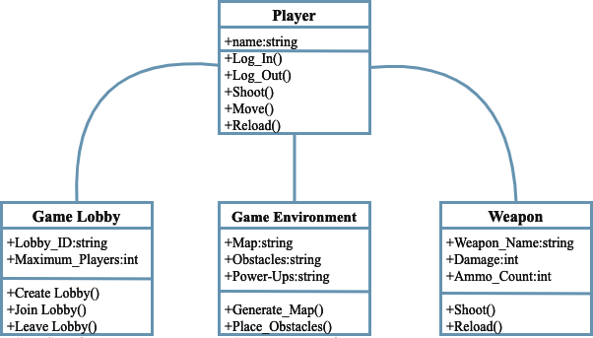

Figure 4.2 Domain Model

Entity-Relationship Diagram (ERD) for a multiplayer shooting game. An ERD is a visual representation of the database schema and the relationships between entities. an ERD for a multiplayer shooting game, and in a real-world scenario, the ERD might include additional entities and relationships based on the complexity of the game and its features.
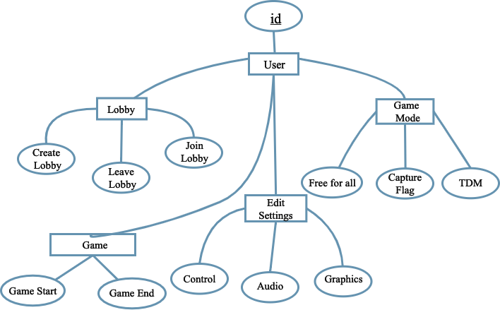

Figure 4.3 Entity Relationship Diagram

Class diagram can be quite extensive and might include various classes, attributes, methods, and relationships. an actual multiplayer shooting game, the class diagram may include more classes and complex relationships to model all the game's features and interactions. In this game classes diagram includes:
- Player
- Game lobby

- Game environement
- Weapon


Figure 4.4 Class Diagram

In a sequence diagram for a multiplayer shooting game, the interaction between players and the game server during a match is illustrated. It includes events such as players shooting each other. For example, when "Player A" requests to shoot, the message is sent to the game server. The server notifies "Player A" of the shoot request and checks its validity, determining if "Player B" is hit. If the shot is valid, "Player B" is notified of being hit. This sequence depicts the basic flow of shooting actions between players and the game server in a multiplayer shooting game.
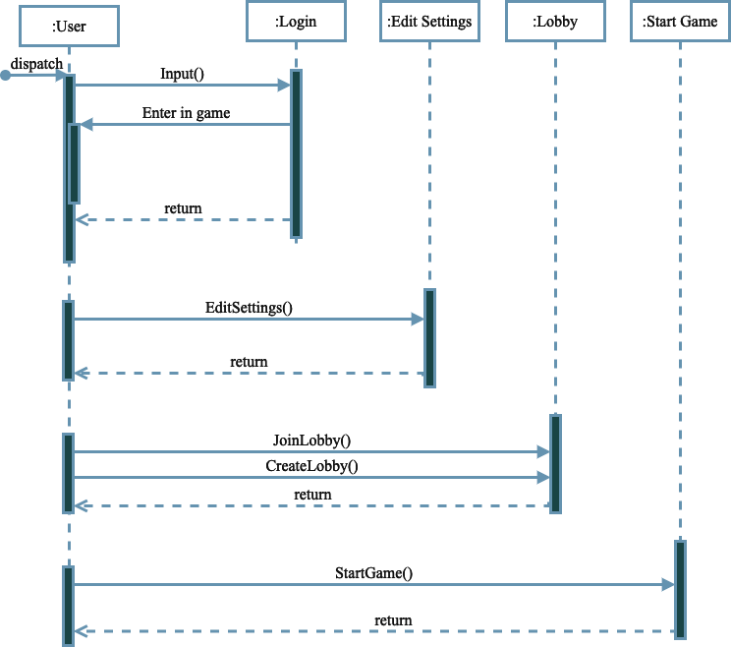

Figure 4.5 Sequence / Collaboration Diagram

Operation Contracts #1

Table 4.1 Operation Contracts-01

Operation Name: | Login (username)
Cross Reference: | Use case Login
Pre-condition: | User should be online
Post-condition: - | User will be successfully log in and enter into the timeline  Objective: User  Attribute: (username)  Association: the relationship between user and login

Operation Contracts #2

Table 4.2 Operation Contracts-02

Operation Name: | Edit Settings (General, Graphics, Audio, Controls)
Cross Reference: | Use case Edit Settings
Pre-condition: | User should be online
Post-condition: - | User will be associated with profile (login)  Objective: User  Attribute: (General_Settings, Graphics_Settings, Audio_Settings, Controls_Settings)  Association: relationship between user and Settings

Operation Name: | Join Lobby
Cross Reference: | Use case Join Lobby
Pre-condition: | User should be logged in and online
Post-condition: - | The Lobby joined randomly  Objective: User  Attribute: Free for all, Capture flags, Team death match  Association: the relationship between user and lobby

Operation Contracts #4

Table 4.4 Operation Contracts-04

Operation Name: | Create Lobby
Cross Reference: | Use case Create Game Lobby
Pre-condition: | User should be logged in and online
Post-condition: - | User created game lobby successfully  Objective: User  Attribute: (game mode, max players, room time limit, game goal, after finish, team selection, bots) Association: relationship between user and Lobby

Operation Name: | Start Game
Cross Reference: | Use case Start Game
Pre-condition: | User should be logged in and online
Post-condition: - | Game start successfully  Objective: User  Attribute: (move, shoot, reload, interact with object, check stats)  Association: relationship between user and game

Operation Contracts#6

Table 4.6 Operation Contracts-06

Operation Name: | Logout (user Id)
Cross Reference: | Use case Logout
Pre-condition: | User should be logged in and online
Post-condition: - | User will be logged out Objective: User Attribute: (user Id)  Association: the relationship between user and Logout

4.7. Activity Diagram
In the activity diagram of a multiplayer shooting game, players join the lobby, select game settings, and proceed to gameplay. During the match, they engage in shooting actions and interact with the game environment. Decision points check for hits and match objectives. The diagram visually represents the dynamic flow of activities in the game, ensuring a concise overview of the gameplay process.
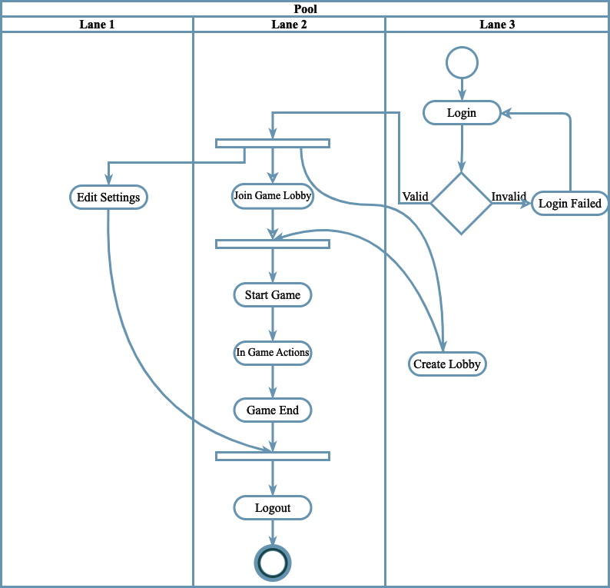
Figure 4.6 Activity Diagram

A State Transition Diagram, also known as a State Machine Diagram, represents the various states and transitions of an object or system. For the "Guest Login" use case, the State Transition Diagram will illustrate the different states that a guest user can go through during the login process. Since the "Guest Login" use case involves a simple login without credentials, the diagram will be relatively straightforward.
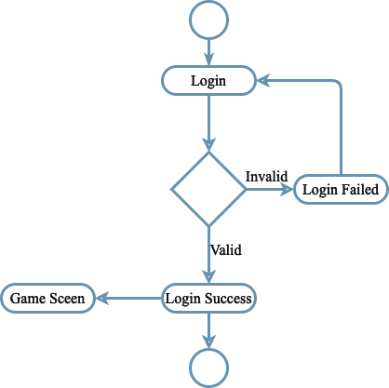

Figure 4.7 State Transition Diagram (Login)

A State Transition Diagram for the "Edit Settings" use case would typically involve representing the different states and transitions that occur when a player accesses and modifies the game settings.
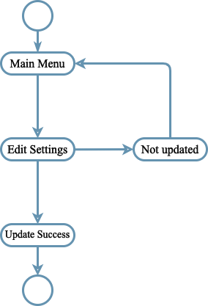

Figure 4.8 State Transition Diagram (Edit Settings)

State Transition Diagram for the "Join Lobby" use case involves representing the different states and transitions that occur when a player joins an existing multiplayer lobby to participate in online matches.
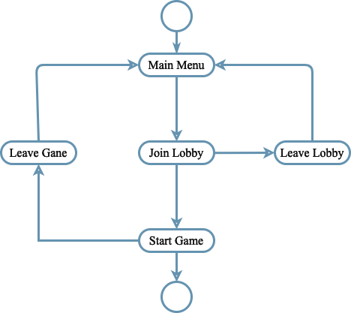

Figure 4.9 State Transition Diagram (Join Game Lobby)

A State Transition Diagram for the "Create Lobby" use case involves representing the different states and transitions that occur when a player creates a new multiplayer lobby to host a custom game session.
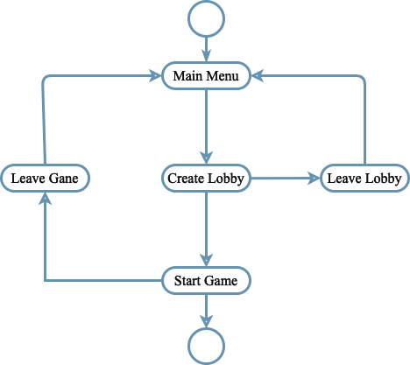

Figure 4.10 State Transition Diagram (Create Lobby)

A State Transition Diagram for the "Start Game" use case involves representing the different states and transitions that occur when a player initiates the beginning of a single-player or multiplayer match.
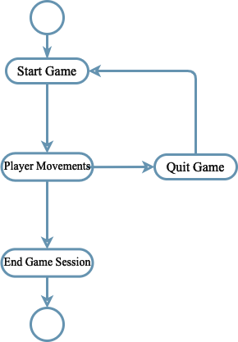

Figure 4.11 State Transition Diagram (Start Game)

The multiplayer shooting game comprises client-side components like User Interface, Game Logic, and Input Manager, and server-side components like Game Manager, Player Manager, and Physics Engine. Networking Modules handle communication, Data Serialization ensures data transmission, and external services provide authentication. Player information is stored in databases. Overall, the architecture enables a captivating multiplayer shooting experience.
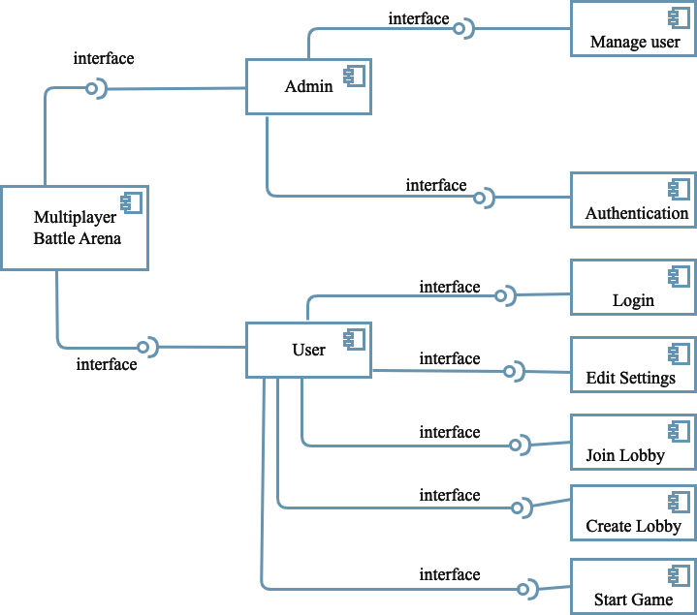

Figure 4.12 Component Diagram

The deployment diagram for the multiplayer shooting game shows Game Clients on devices, communicating with the Game Server running Game Manager, Player Manager, Physics Engine, and Matchmaking System. Networking Infrastructure facilitates data transfer, while External Services handle authentication. Databases store player accounts and game data, and a Game Assets Repository stores media files. Overall, this diagram visualizes the physical setup for delivering the multiplayer shooting experience.
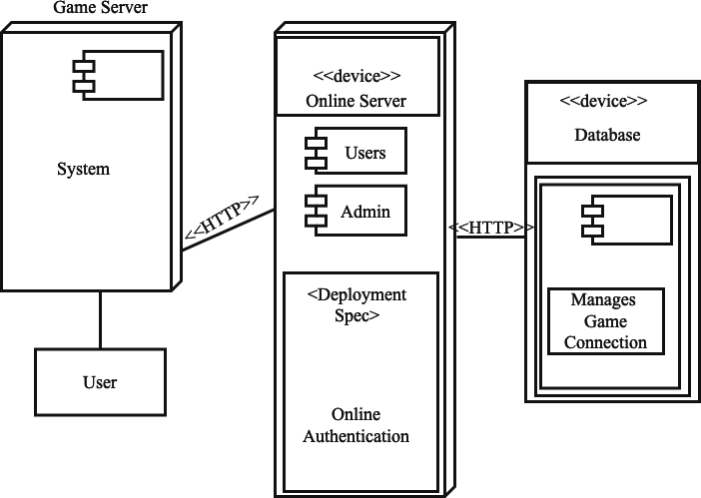

Figure 4.13 Deployment Diagram

Splash Screen

Splash Screen is the first loading screen which always show when the game opened, during this loading screen game connected to the server. The splash screen of the shooting game is the initial screen that appears when the game is launched, serving as an introduction or loading screen before the main menu or gameplay. It often includes the game's logo, title, and perhaps some visual effects or animations.
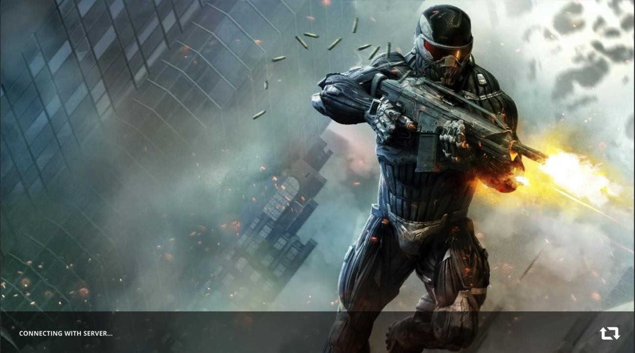

Figure 4.14 Splash Screen

The guest login screen of the shooting game is the initial screen that allows players to access the game without requiring them to create an account or log in with existing credentials. It offers a quick and hassle-free way for players to start playing the game as a guest. After splash screen, login screen appear in which automatically guest name appears user can change the name or login with the given name and click on continue button.
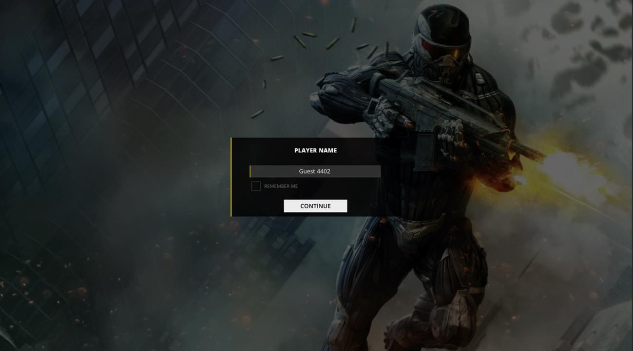

Figure 4.15 Login Screen

After successfully login, main menu screen will be on screen. Through main menu screen user can choose multiple options like:
      - Play
      - Options
      - Logout

      - Quit
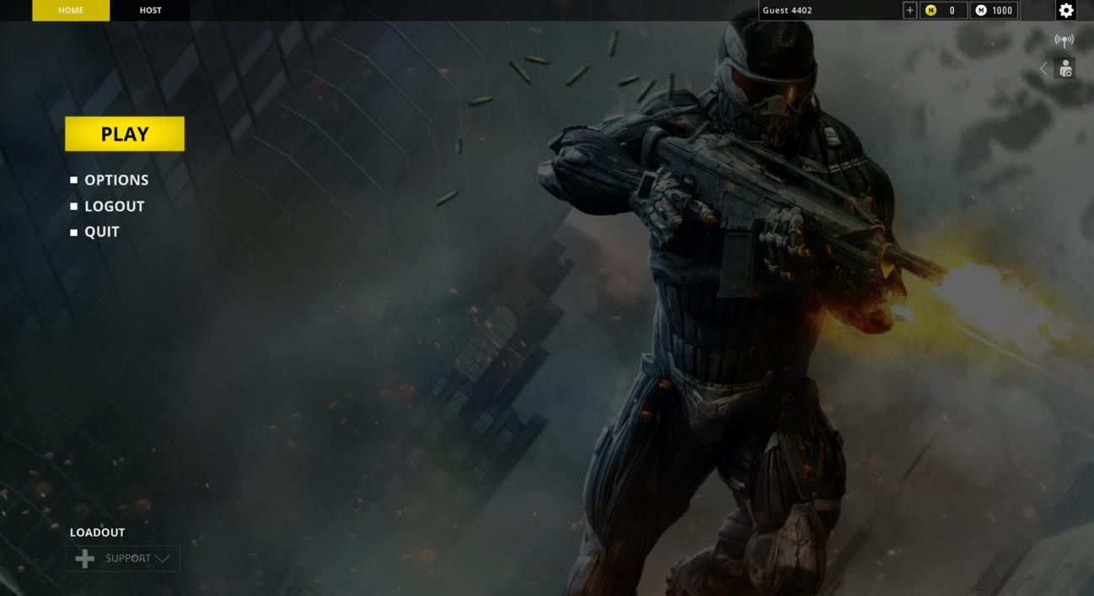

Figure 4.16 Main Menu Screen

In general settings, user can change 3 things, show frame rate, refresh rate in seconds and weapon projection according to his needs. Below the options include in general settings:
      - Show frame rate
      - Refesh rate
      - Weapon projection
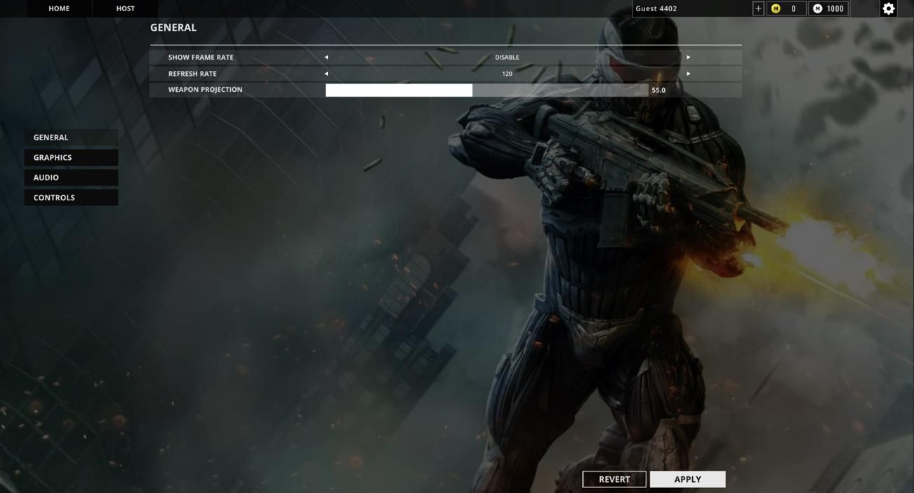

Figure 4.17 General Settings

In graphics settings, user can change the graphics settings according to his system requirements to run the game fast in his/her system. Some of the graphics settings includes:
      - Display mode
      - Resolution
      - Quality

      - Motion blue
      - Bloom
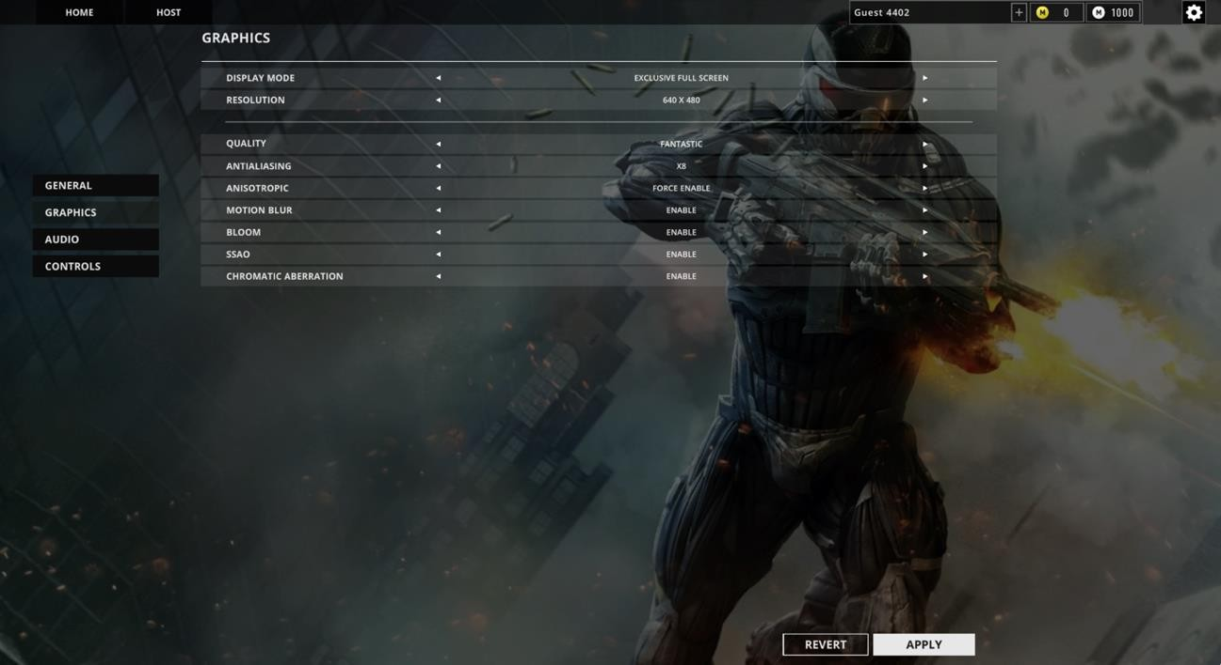

Figure 4.18 Graphics Settings

In audio settings, user can increase and decrease the volume and music of the game according to his needs. Audio Settings includes:
      - Audio
      - Volume
      - Music Colume

      - Voice Chat
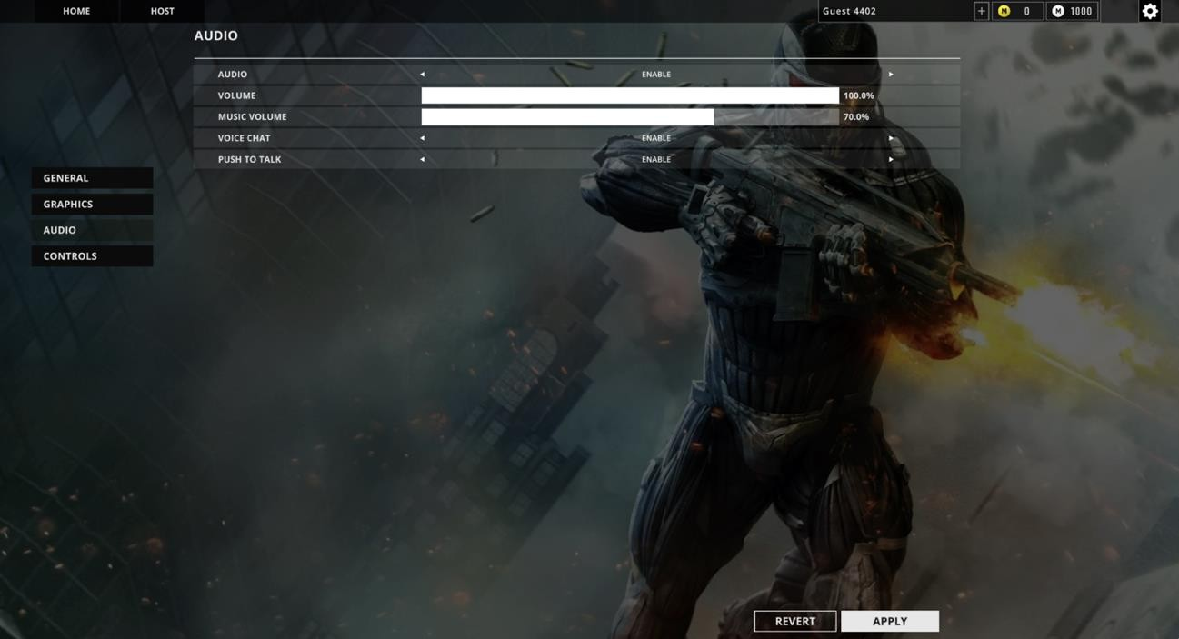

Figure 4.19 Audio Settings

In controls settings, user can change the controls buttons that is suitable for him/user. After change must click on apply otherwise control settings should not be saved. Some of the controls are given below:
      - Mouse Sensitivity
      - Aim Zoom
      - Device input source

      - Keyboard controls settings
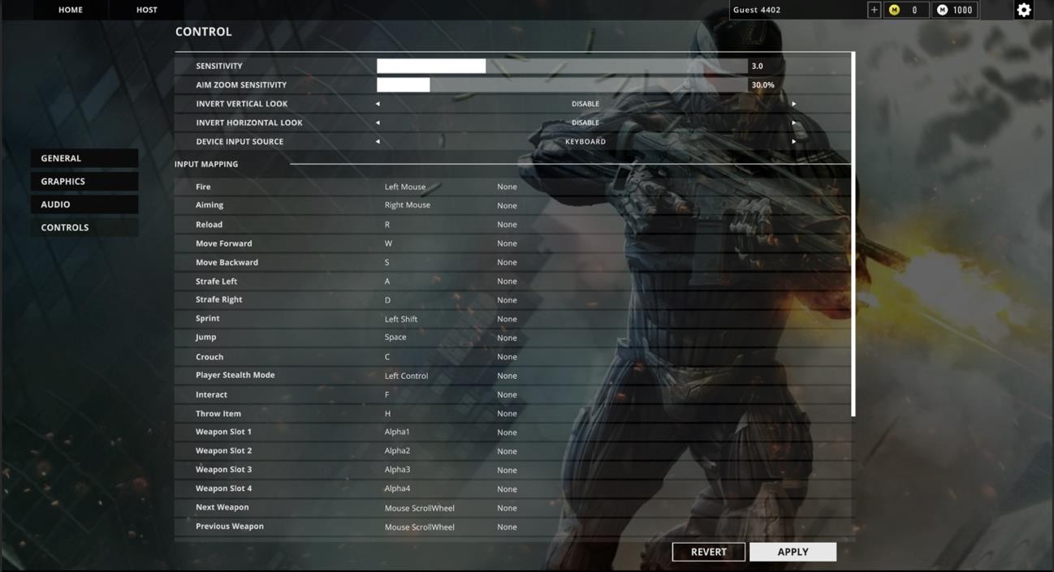

Figure 4.20 Controls Settings

Create lobby for the team death match must select the option of team death match while creating the lobby and click on create. Options to create this lobby includes:
      - Choose Team Death Match Mode
      - Select Players
      - Select Time

      - Select Bots
      - Select Game Mode Goal
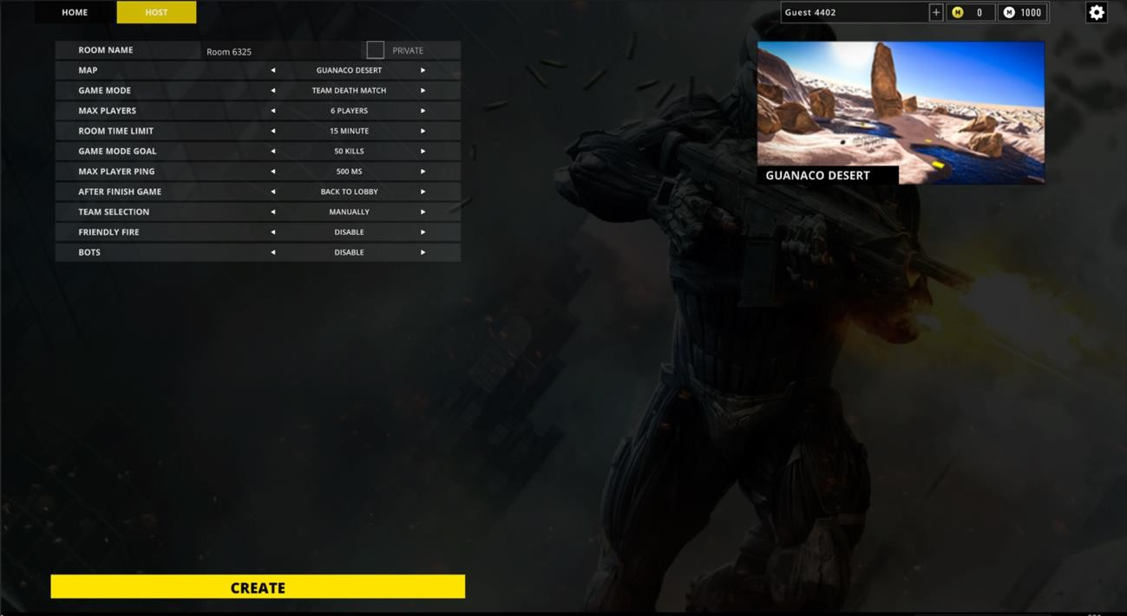

Figure 4.21 Create Lobby Team Death Match Mode

Create lobby for the Capture of Flag must select the option of team death match while creating the lobby and click on create. Options to create this lobby includes:
      - Choose Capture of Flag Mode
      - Select Players
      - Select Time

      - Select Game Mode Goal

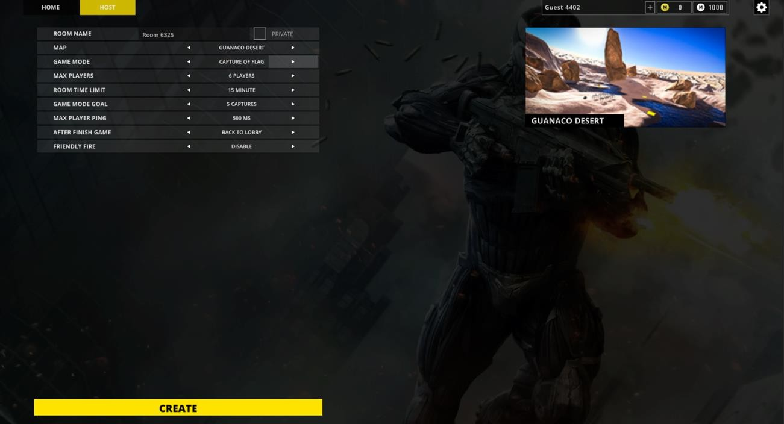

Figure 4.22 Create Lobby Capture of Flags Mode

Create lobby for the Free for all mode user must select the option of team death match while creating the lobby and click on create. Options to create this lobby includes:
      - Choose Free for All Mode
      - Select Players
      - Select Time

      - Select Game Mode Goal
      - Enable/Disable Bots
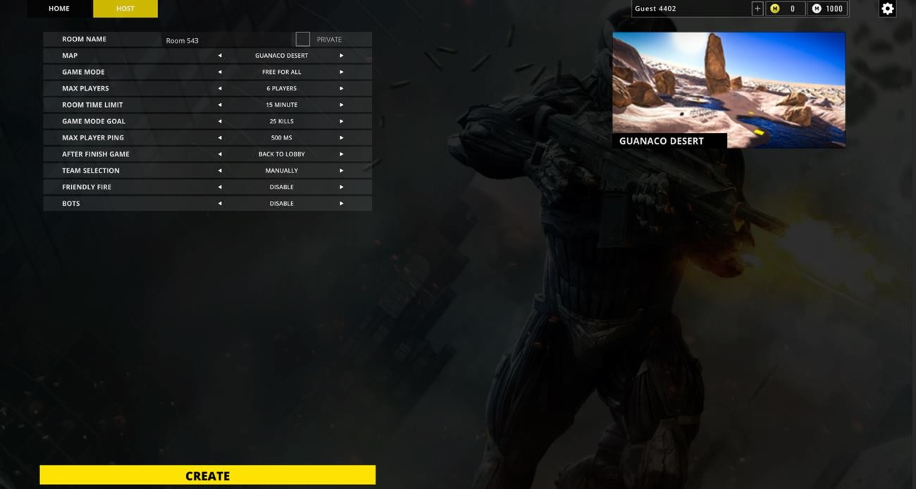

Figure 4.23 Create Lobby Free for All

The lobby screen in a shooting game is a central hub where players gather before entering multiplayer matches. It serves as a meeting point for players to form teams, choose game modes, customize loadouts, and interact with each other. Start the game from the lobby, user have to click on start button to play the game.
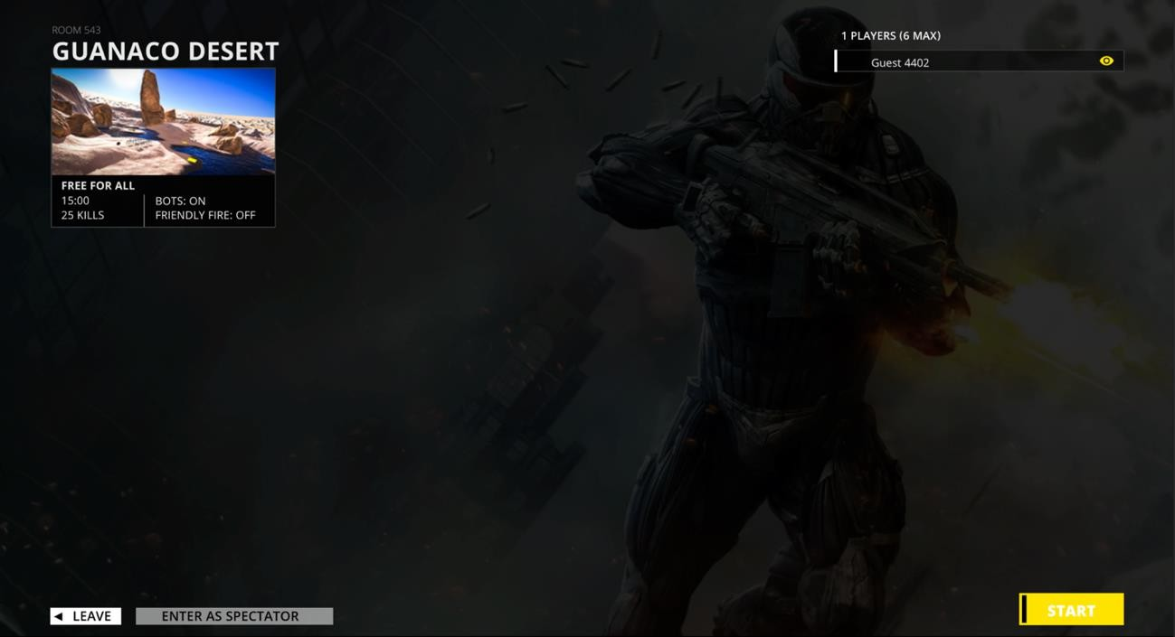

Figure 4.24 Lobby

Gameplay screen where user can play the game and kill other enemies to win the game. Here user can:
      - Move
      - Shoot
      - Reload

      - Crouch
      - Run
      - change weapons
      - pick/drop weapons
      - exit the current game session
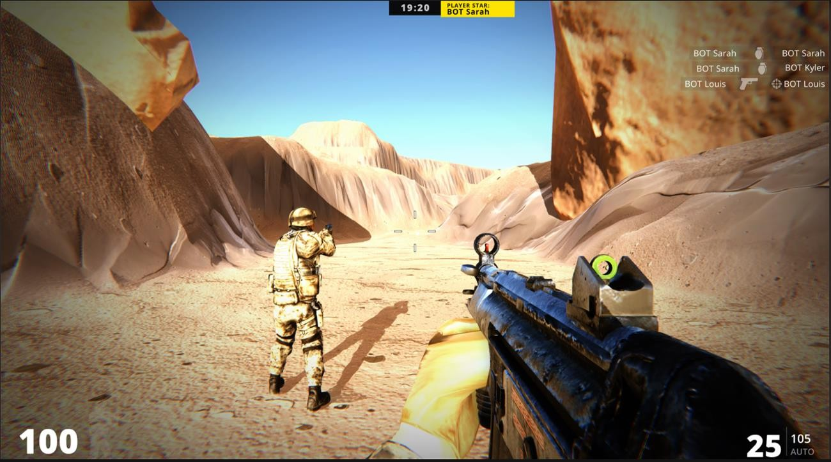

Figure 4.25 Gameplay

The scoreboard in a multiplayer shooting game is a visual representation of the current standings and performance of players or teams during a match. It provides valuable information about their kills, deaths, assists, and other relevant statistics. By click “TAB” button, user can see the scoreboard of the current gameplay session.
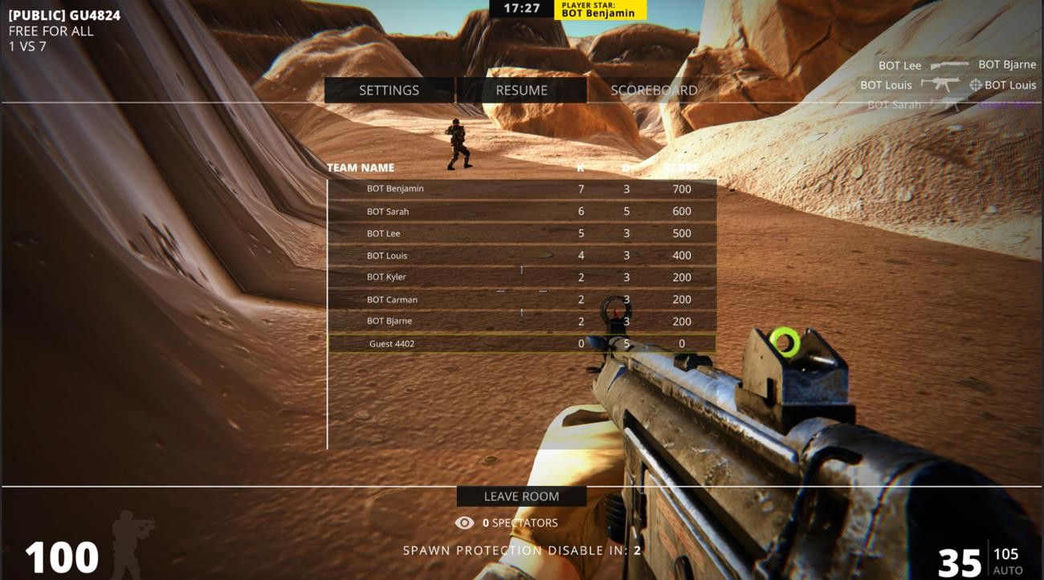

Figure 4.26 Scoreboard

CHAPTER 5 IMPLEMENTATION

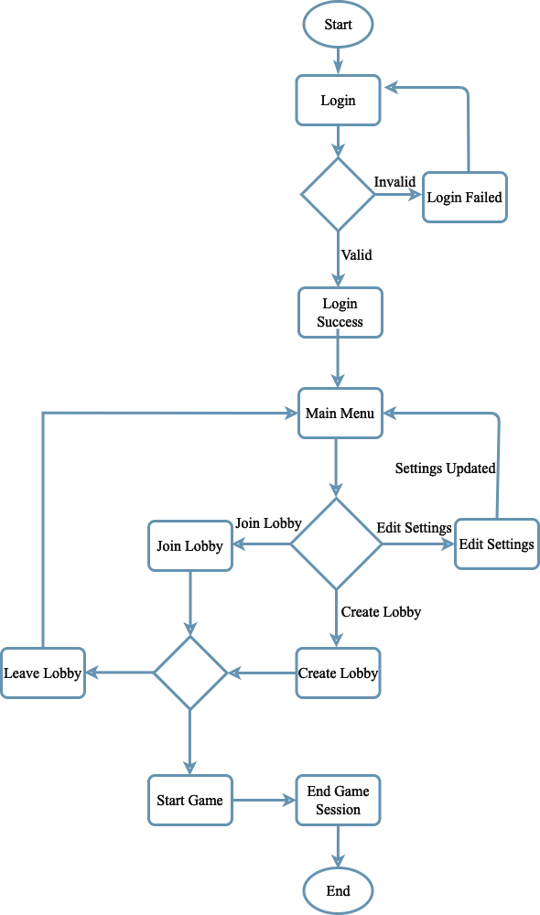

Figure 5.1 Important Flow Control

Libraries
Libraries are a collection of diverse functions that are utilized in the creation of a project to make the various functions easier to perform. The functions are linked to the libraries, making it simple to conduct tasks across many activities. A list of the many libraries used in our project is provided below.
- Unity Libraries

- Photon Unity Networking

Deployment Environment

    - Unity 3D
    - C#
    - Android Studio
    - Visual Studio

    - MacOS Montery

Tools and Techniques

    - C#
    - Android Studio
    - Visual Studio

    - Unity 3D
    - Photon Unity Networking
    - Blender
    - Adobe Illustrator

    - Code should not have any trailing whitespace to avoid creating unnecessary diff issues.
    - Function and classes are always commented on showing expected input and output

    - GUI should be user-friendly
    - Let photos say what you can’t say
    - Document everything
    - Demand for Feedback

CHAPTER 6
TEST AND EVALUATION

Testing is a procedure for detecting problems in a program. We execute a simulation test on the system to ensure that any errors or bugs are not there. Various scenarios and forms of testing will be used to determine whether or not the system is functioning properly. If any faults are discovered throughout the testing, provide a solution to the errors. In this chapter, we cover the entire system testing and assessment process, including how to use the system and what work each feature has completed.

Use Case Testing

Various scenarios, such as user and multiplayer functionality, are being tested throughout this session.
Use Case Testing is a software testing technique that helps to identify test cases that cover entire system on a transaction-by-transaction basis from start to end. Test cases are the interactions between users and software application. Test cases based on use cases and are referred as scenarios. Capability to identify gaps in the system which would not be found by testing individual components in isolation. Very effective in defining the scope of acceptance tests.

Table 6.1 Use Case Testing-01

Actor: | User
No. |  | Steps | Description
1 |  | Login | Login to the system with guest name  System will redirect to next page
2 |  | Edit Settings | Change the settings of the game according  to your systems and your mindset
3 |  | Create Game Lobby | Create game lobby according to your  interest.
4 |  | Join Lobby | Join any random lobby to play the game.
5 |  | Start Game | Start the game-play and kill the enemies to  win the game.
6 |  | Logout | Logout success with press logout button  System will redirect to login page

The main success scenario of a multiplayer shooting game outlines the sequence of events that occur during a typical and successful gameplay experience. The main success scenario ensures that players have an engaging and enjoyable experience, with challenging gameplay, opportunities for teamwork, and a sense of progression. The game's mechanics, visuals, and level design all contribute to creating a thrilling multiplayer shooting game that keeps players coming back for more action and excitement.

Table 6.2 Use Case Testing Extension

No. | Step | Description
1-a | Login failed | Login failed if user did not have internet.  System will display an error message
2-a | Lobby connection  failed | Lobby connection failed if your internet  connection is not stable
3-a | Lobby suddenly leave | Lobby suddenly leave if your internet  connection lost during game
4-a | Lobby created failed | Lobby creation failed if your internet  connection is not stable.
5-a | Game-play stucks | Game-play stucks if your internet  connection lost.

Boundary Value Analysis

Boundary testing is a type of testing that takes place between a starting point and the extreme ends of a range of input values, or between partials of input values.

Login Username
    - A person's username must be unique when entering it in the text field during login.

Text Fields
    - The system must allow only correct text in all text fields.
    - The user must add only the information that is required and brief.
    - Name is examples of text fields.

Test Case Title: System Response Time Testing

Table 6.3 Performance Testing 01

Test Type | Performance Testing | Test Result
Required performance | The required response time of the  system is less than 10 seconds
System performance | The actual performance response time  is 5 seconds. | Test passed

Test Case Title: Activity Load Time Testing

Table 6.4 Performance Testing 02

Test Type | Performance Testing | Test Result
Required performance | The required page load time of  the system is less than 5 seconds
System performance | The actual page load time is 2  seconds. | Test passed

Table 6.5 Performance Testing 03

Test Type | Performance Testing | Test Result
Required performance | System should perform normally and efficiently with a large number of  users
System performance | System performed all activities  normally with a large number of users. | Test passed

Test Case Title: Waiting Time Testing

Table 6.6 Performance Testing 04

Test Type | Performance Testing | Test Result
Required performance | The average waiting time of the  system is less than 5 seconds
System performance | The actual performance response  time is 3 seconds in some circumstances. | Test passed

Table 6.7 Performance Testing 05

Test Type | Performance Testing | Test Result
Required performance | The connection must be established  in less than 3 seconds
System performance | The actual connection establishes time is about 2 second. | Test passed

Test Case Title: Database Send/Get Information Time Testing

Table 6.8 Performance Testing 06

Test Type | Performance Testing | Test Result
Required performance | The system should save or retrieve  data from database in less than 2 seconds.
System performance | The actual time system sends or gets information to database in 1  second. | Test passed

Stress testing is a method of determining a system's stability and dependability. Stress testing is a technique for determining a system's ability to handle flaws and faults. Stress testing is a technique for evaluating a system's ability to handle errors under harsh conditions.
We overload our system and analyze its behavior in extreme settings to confirm that it behaves normally during stress. In bad conditions, the (Multiplayer Battle Arena) Game behaves regularly, and all of its features and functions work as expected.
Through this testing, we monitor our system and make sure our system

- System should save all data before crashing
- Make sure the connection from server
- If server0 no response, wait on login current page

As we all know, there is always room for improvement in every management system. The following are some basic changes that we should make in the future:

Add More Environments
To improve the game difficulty and enjoyment, need to add more environments that will be selectable by users. The more levels to get, the more user will play.

Game Quality
For use, quality is quite crucial. Always keep a close eye on quality control and never skimp on it. The higher the quality, the better.

System Level
Our system should not be clogged with too much data. We should only give the user with the most basic information. Otherwise, the user may feel perplexed and will be unable to use our game.

Add More Modes
Besides the 3 Modes, I am thinking to add more new mods in the multiplayer game to enjoy more in the game.

REFERENCES

- Technologies, U. (2023, 7 7). Unity Manual. Retrieved from Unity Documentaion: https://docs.unity3d.com/Manual/index.html
- Systems, A. (2021, 9 15). Character. Retrieved from Mixamo: https://www.mixamo.com/#/
- Shutterstock. (2021). Turbo Squid. Retrieved from Turbo Squid: https://www.turbosquid.com/
- Free3D. (2014, 12 9). Retrieved from Free3D: https://free3d.com/

- Google. (2005, 2 14). Youtube. Retrieved from Youtube: https://www.youtube.com/

- GitHub, I. (2022, August). Github. Retrieved from Github: https://github.com/
- Technologies, U. (2018). assetstore. Retrieved from Unity assetstore: https://assetstore.unity.com/
- Wikipedia. (n.d.). Wikipedia. Retrieved from Wiki Pedia: https://www.wikipedia.org/
- Brakeys. (2012, December 23). Brackeys. Retrieved from Youtube: https://www.youtube.com/channel/UCYbK_tjZ2OrIZFBvU6CCMiA
- Data, R. (1999). cs/index.php. Retrieved from w3schools: https://www.w3schools.com/

